Security Holes: Security has no security

Note:
The way I understanding it we basically have two completely separate security systems that serve different purposes independently. I believe the Umbrella Security settings (1-9) serve primarily to show or hide specific menu items and/or links. Then we have our internal Security Groups implemented within our .NET code throughout the IntranetSite environment (and SOE and WOE, etc). This basically allows/prevents access to specific functions/pages/code as it is specifically programmed.

The major concern is that even a user with Umbrella Security = 3 can access the Support Table Dashboard or other programs directly and therefore run Security Groups Maintenance, User Master Maintenance or any of those other maintenance apps. The biggest hole is that in accessing the User Master Maintenance, there appears to be no internal security settings preventing the user from modifying any of the individual Security Groups settings.

Scenario:
I am logged into LIVE as Robin in Cleveland (rmarchetti - Umbrella level 3). As expected, I do not see the Security Administration button link in the top menu bar because it is set to Umbrella 9 (note in QA this is not set to 9).

LIVE
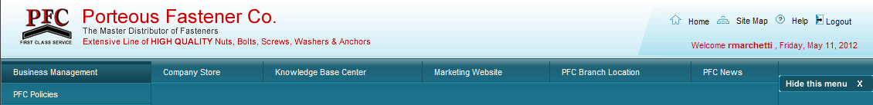

QA
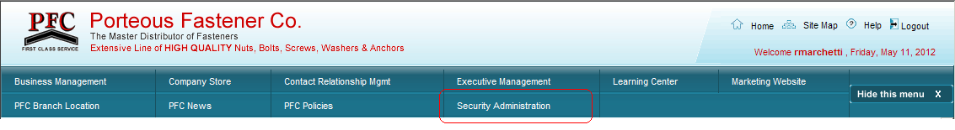

Regardless if I can see the button or not, knowing the actual link to the Support Table Dashboard, I can navigate there directly: http://pfcintranet/intranetsite/MaintenanceApps/SupportTableDashboard.aspx and now I have access to all of the Security Support Table maintenance apps.

Now, suppose I try to execute Vendor Maintenance. OK, since Robin does not have a valid Vendor Maintenance Security Group set, it redirects her to the common unauthorized page: “Warning ! You are not authorized to view this page. Please contact administrator.“ Perfect, right?

Unfortunately, this is rendered moot by the fact that I can open User Master Maintenance from the same menu and essentially grant/deny any security group to any user! I believe the User Master Maintenance page (at minimum the “User Security” tab) should require a special group setting to be able to access it at all. And if we are relying on the Umbrella security levels to keep users out of any other programs we should seriously consider verifying their internal Security Group settings.

Of course, if you set individual menu items within the Support Table Dashboard to Umbrella 9; then, yes, we could individually hide the User Master (and other) menu item(s) from the dashboard. However, without implementing specific Security Groups within the aspx pages, a user could still gain access through direct program links like: http://pfcintranet/intranetsite/EmployeeData/UserMaster.aspx

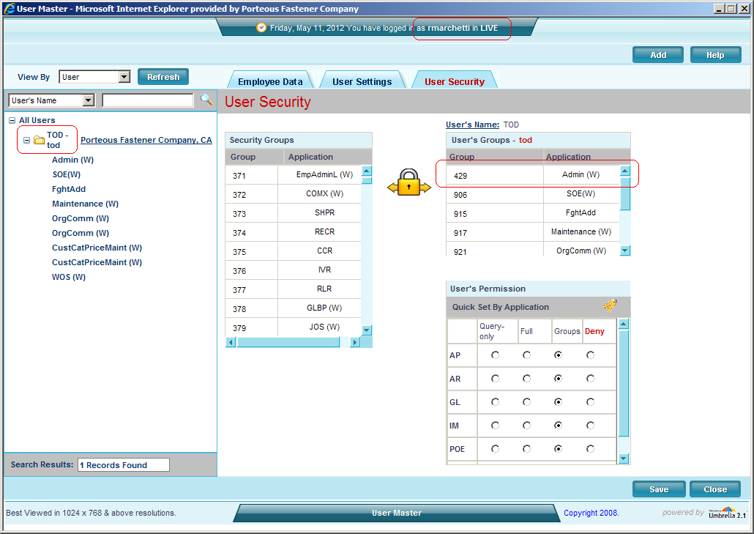

I didn’t really want to mess with it but I was able to use Robin’s account to pull up my user record and grant myself Admin group access (and then I was able to take it away again).

